Worked Example 4: High sensitivity cardiac troponin for diagnosing non-ST elevation myocardial infarction
Note: Purple text indicates completed answer

QUADAS-3 aims to help in the evaluation of the risk of bias and concerns regarding applicability for each set of estimates of test accuracy included in your review. The tool includes six phases. Phases 1 and 2 are completed at the review level, phases 3 and 4 at the study level, and phase 5 and 6 are completed for each selected set of estimates. We recommend including the review level phases as part of your review protocol. Table 1 summarises the phases included in the QUADAS-3 tool with details of when each phase should be completed and which section of the tool should be completed for each phase.

Please read the QUADAS-3 Explanation & Elaboration report before using QUADAS-3. This provides a detailed overview of how to complete each phase. Consider whether any review-specific guidance for individual signaling questions is needed.

Table 8: Overview of the phases included in the QUADAS-3 tool with details of when each phase should be completed and which section of the tool should be completed for each phase
Phase | When to complete | Section to complete
Phase 1: State the systematic review synthesis question(s) | Once per review | Table 2
Phase 2: Define the ideal test accuracy trial for each synthesis question | Once per review | Table 4
Phase 3: Flow diagram | Once per study | Box 1
Phase 4: Identify the accuracy estimates to assess for risk of bias and applicability | Once per study | Table 5
Phase 5: Assess risk of bias and concerns regarding applicability | For each selected estimate | Individual domain
Phase 6: Overall judgment | For each selected estimate | Summary tables

Phase 1: State the systematic review synthesis question(s) [once per review]
A single review may address more than one synthesis question. The first phase of the QUADAS-3 assessment is to clearly specify the question(s) that will be addressed by the systematic review synthesis. This should also be pre-specified in your review protocol. Consider including the following components: population, index test(s), and target condition. For reviews involving comparative accuracy, we recommend using the QUADAS-C tool in addition to QUADAS-3.

Table 2: Definition of systematic review synthesis questions
Question 1 | What is the diagnostic performance of high sensitivity cardiac troponin (hs-cTn) assays for the early rule-out of non-ST elevation myocardial infarction (NSTEMI) in adults with acute chest pain?

Phase 2: Define the ideal test accuracy trial for each synthesis question [once per review]
For each synthesis question defined in Phase 1, define the ideal test accuracy trial that could be conducted in a clinical setting. An ideal test accuracy trial should produce unbiased estimates of test accuracy. An ideal trial is a theoretical construct as such a trial design may not be achievable in practice because of ethical and resource constraints.

Defining the ideal test accuracy trial serves as a benchmark for identifying how real-world deviations observed in a particular study may introduce risk of bias or raise concerns about applicability.

The ideal trial to evaluate a test strategy should be based on the following design template, adapted to your review question, and should ensure that the design both minimises the risk of bias and maximises the applicability of the trial to each synthesis question. A test strategy encompasses one or more tests used together but accuracy is estimated for the strategy rather than for the individual test components. Table 3 provides a framework to help you define the ideal test accuracy trial for each synthesis question, recognising that some components may be replicated across individual synthesis questions in a review (for example a review of more than one index test in the same population).

Table 3: Framework to define the ideal test accuracy trial. Use this information to help you complete Table 4.
Component | General features
Overall | - Pre-specified protocol.  - Sufficient total sample size to expect adequate numbers of participants with and without the target condition to generate sufficiently precise estimates of test accuracy (e.g. sensitivity and specificity).
Objective | - Assess the accuracy of the index test(s) in its proposed role and position in the clinical pathway, including the clinical decision that the test is informing.
Participants | - Prospective enrolment of a single group of consecutive or random group of eligible participants suspected of having the target condition.  - Participants are a representative sample of the intended-use population, as defined in the synthesis question.  - Details of symptoms and prior test results of included patients reported.
Index test | - Index test should be the appropriate technical version of the index test, conducted using recommended instructions and in the intended role in the clinical pathway.  - Performed after recruitment of trial participants.  - Interpretation of the index test result should not be affected by external information that would not usually be available to the person interpreting the test in its proposed role in practice e.g. information on the reference standard, disease state, or additional test results.  - Test conducted by operators who would usually conduct and interpret the test in practice, in a setting representative of the review question  - Definition of threshold(s) to classify test results as positive or negative pre-specified.
Definition of the target condition | - Reference standard and reference standard threshold should correctly classify all participants as having or not having the target condition.  - Protocol for undergoing the reference standard is the same for all study participants, and the reference standard is performed in all participants.  - Reference standard performed after recruitment of trial participants.  - Reference standard interpretation is independent of the index test; those interpreting the reference standard should not be aware of the index test results, and the index test should not be part of the reference standard where a composite reference standard is used.  - The time between the index test and reference standard is sufficiently short to be confident that the disease status has not changed.
Analysis | - All participants included in the analysis.  - Unit of analysis appropriate for the synthesis question.  - Appropriate methods used to calculate estimates of accuracy (e.g. sensitivity and specificity).

For each synthesis question in Table 2, define the ideal trial in Table 4. Use the information in Table 3 as a guide.

Table 4: Definition of the ideal test accuracy trial for each systematic review synthesis question in Table 2
Component | Synthesis Question 1
Objective | To evaluate the accuracy of hs-cTn when used at presentation and early repeat testing in adults with acute chest pain, to inform the clinical decision to safely rule out non-ST-elevation myocardial infarction and enable early discharge.
Participants | Consecutive prospective enrolment of adults (≥18 yrs) presenting in secondary or tertiary care with acute symptoms of a suspected, but not proven, acute MI who do not have ST elevation on their ECG
Index Test(s) | - Hs-cTn assay with results available within 3 hours or presentation  - The study should evaluate one of the following assays: Abbott ARCHITECT high-sensitivity troponin I assay; AccuTnI+3 troponin I assay (Beckman Coulter) and Roche Elecsys high-sensitivity troponin T assay  - Assays should be conducted according to manufacturer’s instructions and should be conducted as a single diagnostic test not as part of testing strategy  - Performed after participants have been enrolled into the study
Definition of the target condition | - Non-ST-elevation myocardial infarction (NSTEMI), defined using third universal definition of AMI, including: measurement of troponin T or I (using any method) on presentation and 3-6 hours later; or occurrence of major adverse cardiac event (MACE) during 30 day follow-up.  - Diagnosis may utilise results of the hs-cTn assay to assess change in troponin levels, but reference standard should be interpreted without knowledge of the initial hs-cTn assay results  - Reference standard should be performed after recruitment of trial participants.  - All enrolled participants should receive the same reference standard
Analysis | - All participants included in the analysis.  - Appropriate methods used to calculate estimates of accuracy (e.g. sensitivity and specificity).  - Analysis at the participant level

Phase 3: Draw a flow diagram [once per study]:
Draw a flow diagram for the primary study to provide a visual summary of how participants and test results underlying accuracy estimates progress through a primary study. This would usually be done at the study level and would portray the flow of participants and test results for all estimates specified in Phase 4. You may need to draw separate diagrams for the different synthesis questions.

Reference of paper being assessed:
Slagman A, von Recum J, Mockel M, Holert F, Meyer zum Buschenfelde D, Muller C, et al. Diagnostic performance of a high-sensitive troponin T assay and a troponin T point of care assay in the clinical routine of an Emergency Department: a clinical cohort study. Int J Cardiol 2017;230:454-460.

Box 1: Flow diagram
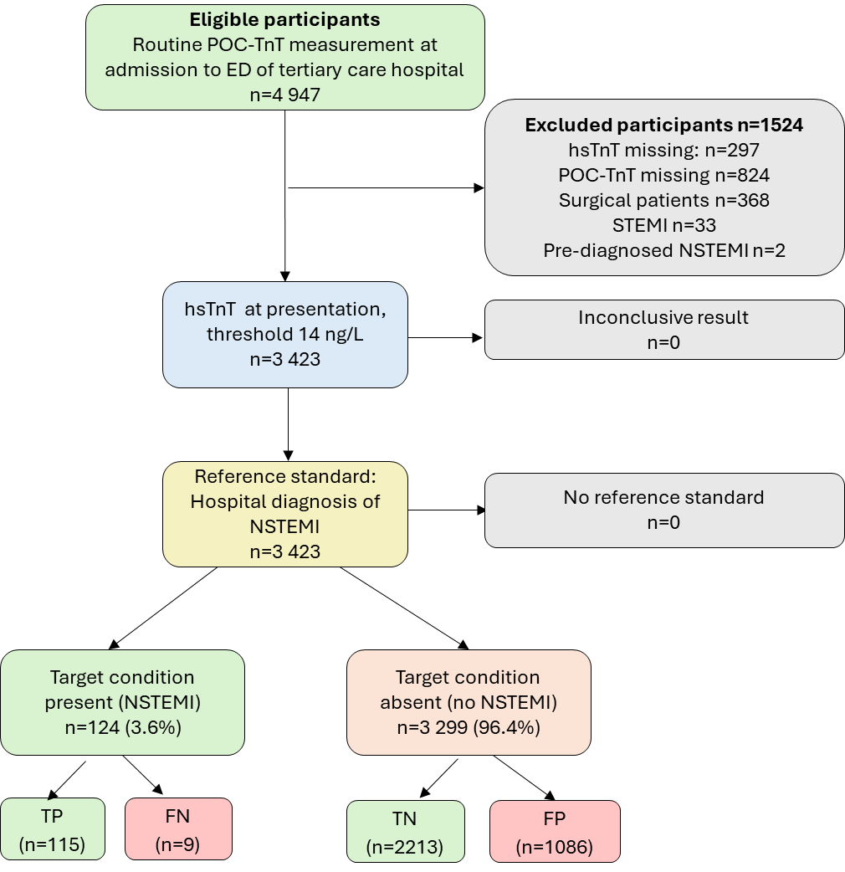

Phase 4: Identify the numerical accuracy estimates to assess for risk of bias and applicability [once per study]
For each synthesis question, it is often possible to calculate multiple estimates of sensitivity and specificity (i.e. multiple two-by-two tables) from the data presented in a study. Multiple estimates within a specific study may occur due to differences in study subgroups, index tests, definitions of the target condition, reference standards, units of analysis, and thresholds. The potential risk of bias and applicability issues may differ according to the estimate.

Not all estimates reported in a primary study will be relevant for your review; you should only extract and assess those estimates that are relevant to one of your synthesis questions (defined in Phase 1) and that will contribute to the synthesis (whether narrative or statistical). Deciding which estimates to extract should be considered at the review level and done as part of data extraction – here we ask you to specify which estimates will be included in your review. Only perform QUADAS-3 assessment for numerical estimates that will be included in the review. Please complete Table 5 to identify the numerical accuracy result(s) being assessed.

Table 5: Identification of numerical accuracy estimates(s) to be assessed
 | Estimate 1
Synthesis Question (e.g. Q1, Q2 from table X) | Q1
Numerical test accuracy result e.g. sensitivity=80%  and specificity=76% | Sensitivity = 93% (95% CI: 87 to 97%)  Specificity = 67% (95% CI: 65 to 69%)
Participants | Patients with Hs-TnT measurement at admission, who presented to the ED of a tertiary care hospital.
Index Test | Hs-TnT
Index test threshold (if applicable) | 14 ng/L at 0 hours (on presentation)
Target condition | NSTEMI
Reference standard | Main hospital diagnosis of NSTEMI.
Unit of analysis (e.g. participant, tumour, lesion, sample) | Participant
Analysis (e.g. analysis method, participants included in analysis) | All patients with index test data available
Which QUADAS-3 domains will be assessed (Participants, Index Test, Target condition, Analysis)* | All

Phase 5: Assess risk of bias and concerns regarding applicability [for each selected estimate]
QUADAS-3 is structured as 4 key domains (Participants, Index Test, Target Condition, Analysis) each rated in terms of the risk of bias. Each domain has a set of signaling questions to help judge risk of bias. Signaling questions are answered as:
- yes (Y)
- probably yes (PY)
- probably no (PN)
- no (N)
- no information (NI)

A risk of bias judgment for each domain is based on signaling question answers and is answered as:
- low
- high
- insufficient information (II)

If all signaling questions for a domain are answered “yes” or “probably yes” then risk of bias can be judged “low”. If any signaling question is answered “no” or “probably no” this flags the potential for bias. Review authors then need to use their judgment and review specific assessment guidance to judge whether the potential issue identified is likely to have influenced the estimates of test accuracy – a study can still be at low risk of bias even if one or more signaling questions are answered no. The “insufficient information” category should be used only when insufficient data are reported to permit a judgment.

Three of the four domains (Participants, Index Test, Target Condition) are also assessed for applicability to the synthesis question. Concern regarding applicability to the synthesis question is also judged as:
- low
- high
- insufficient information

If you have specified more than one estimate to be assessed in Table 5, you will need to identify which assessment relates to which estimate.

DOMAIN 1: PARTICIPANTS
A. Risk of Bias
Describe how participants were enrolled e.g. single-gate (a group of participants in whom the diagnosis was not yet known. This could include multiple groups from different locations e.g. different hospitals) or multi-gate (case-control design – participants with known diagnosis): Single-gate.
Describe whether enrolment was prospective or retrospective: Prospective

Describe how participants were selected for enrolment: “All patients with routine TnT testing in the ED were enrolled” and “All patients with routine POC-TnT measurement at admission, who presented to the ED of a tertiary care hospital, were prospectively enrolled in two time periods”

Describe any restrictions to enrolment: None
1.1 Was a single-gate design used? | Y
1.2 Were participants prospectively enrolled? | Y
1.3 Was a consecutive or random sample of participants included? | Y
1.4Is the study group a representative sample of the intended use population? | NI
Risk that the selection of participants has introduced bias | II
No information on why Hs-TnT measurements were taken on admission and so it is not possible to determine if the study group is a representative sample of the intended use population.
B. Concerns regarding applicability to the systematic review synthesis question
Concern that the included participants do not match those in the ideal test accuracy trial | II
Details of presenting symptoms not reported.

Y=yes; PY = probably yes; N=no; PN= probably no; NI = no information; II = insufficient information

DOMAIN 2: INDEX TEST
A. Risk of Bias
Describe the index test: Roche hsTnT assay, blood sample taken on presentation. The study does not explicitly report that the Roche Elecsys assay was used, but we assume that it was as this used the Cobas e602 analyzer mentioned in the description.

Describe whether the index test was conducted and interpreted according to recommended instructions (e.g. following manufacturer’s instructions, following protocol, standard clinical methods): “hsTnT was measured in Lithium-heparinized plasma drawn simultaneously to the EDTA-sample for POCT. Samples were sent to CLT (Central Laboratory Testing) on the Cobas e602 (Roche Diagnostics GmbH, Germany).”

Describe what information was available to those interpreting the index test: Not reported but likely all clinical information available in the ED; reference standard/diagnosis was adjudicated after index test was performed.

If a threshold was used, describe how this was selected (e.g. standard pre-specified threshold, defined a priori within the study, derived from the data): pre-specified threshold (14 ng/L): “The 99th percentile of this assay is 14 ng/L (CV b 10%), the LOD is 5 ng/L. In our own laboratory the assay had a CV of 3.5% at 16 ng/L and 3.1% at 27 ng/L. The conventional cut-off point for AMI rule-in is 50 ng/L as this corresponds to the very well-studied cut-off of conventional assays”

2.1 Was the index test conducted and interpreted according to the recommended instructions? | Y
2.2 Were the index test results interpreted without knowledge of the reference standard results? | Y
2.3 Were the index test results interpreted with the same information as would be available when the test is used in practice? | PY
2.4 If an index test threshold was used, was it standard or pre-specified? | Y
Risk that the conduct or interpretation of the index test has introduced bias | LOW
No concerns
B. Concerns regarding applicability to the systematic review synthesis question
Concern that the index test, its conduct, or interpretation does not match the ideal test accuracy trial | LOW
Index test was consistent with the specification for the ideal test accuracy trial.

Y=yes; PY = probably yes; N=no; PN= probably no; NI = no information; II = insufficient information

DOMAIN 3: TARGET CONDITION
A. Risk of Bias
Define the target condition: NSTEMI

Describe how the target condition was assessed – what reference standard(s) was used and how was it conducted and interpreted: “The endpoint (reference standard) of this study was a main hospital diagnosis of NSTEMI. Diagnoses were retrieved from the hospital information system (HIS) as ICDCodes (International Classification of Disease, Version 10) and were coded by treating physicians.”
“All troponin test results were available to the treating physicians (hsTnT and POC-TnT) and thus the diagnoses were based on both values, serial measurements at 3 h (hsTnT) or 6 h (TnT) and all available clinical information.” Supplementary information describes the reference standard as “The diagnoses are based on the hospital main diagnosis for patients who were admitted to the hospital and on the first ED-diagnosis for patients who were discharged directly from the ED.” The study flow chart indicates that there were no participants with missing reference standard, however, it is not explicitly stated that the reference standard included serial troponin measurement in all cases.

What was the time interval between index test and reference standard: 6-12 hours if using change in HsTnT values as the basis of the final diagnosis

3.1 Does the reference standard adequately identify those with and without the target condition? | PY
3.2 Was the target condition assessed in all participants? | PY
3.3 Was the target condition assessed in the same way in all participants? | II
3.4 Did the reference standard avoid incorporating the index test? | N
3.5 Was the reference standard conducted and interpreted according to the recommended instructions? | PY
3.6 Were the reference standard results interpreted without knowledge of the index test results? | N
3.7 If a reference standard threshold was used, was it standard or pre-specified? | Y
3.8 Was there an appropriate time interval between index test and reference standard? | Y
Risk that the assessment of the target condition has introduced bias | HIGH
The index test, hs-cTnT, formed part of the reference standard adjudication. However, this was most likely based on change in hs-cTnT in serial troponin measurements rather than baseline hs-cTnT alone. This is not as problematic as relying on the baseline measurement alone, but still has the potential to introduce bias. There was also uncertainty about whether and how all participants who were discharged directly from the ED were assessed for NSTEMI.

B. Concerns regarding applicability to the systematic review synthesis question
Concern that the target condition as defined by the reference standard does not match the ideal test accuracy trial | II
Unclear whether the third universal definition of AMI, as specified in the ideal test accuracy trial, was applied

Y=yes; PY = probably yes; N=no; PN= probably no; NI = no information; II = insufficient information

DOMAIN 4: ANALYSIS
Y=yes; PY = probably yes; N=no; PN= probably no; NI = no information; II = insufficient information

A. Risk of Bias
Describe any participants who were enrolled in the study but excluded from the 2x2 table (refer to flow diagram) and reasons why they were excluded (e.g. did not receive index test, did not receive reference standard, uninterpretable index result etc):

A large proportion of participants (1524/4947) were excluded due to missing test data, a post-diagnosis STEMI results, pre-diagnosed NSTEMI and due to being surgical patients. The majority were for reasons of missing test data. Exclusion of STEMI given the objective of measuring accuracy in NSTEMI is reasonable, but this was only 33 participants.

How was any missing 2x2 data, including missing reference standard data, accounted for? Participants with missing data were excluded from the analysis.

What do the numbers in the 2x2 table correspond to? i.e. what is the unit of analysis (e.g. participants, samples, specimens): Participants

Describe any non-standard statistical analyses used to generate the estimates of sensitivity and specificity being assessed (either conducted by the study authors or by you): None
4.1 Were all participants included in the analysis? | N
4.2 Were missing data handled appropriately? | N
4.3 Does the unit of analysis match the synthesis question? | Y
4.4 Were the estimates of sensitivity and specificity calculated appropriately? | Y
Risk that the analysis has introduced bias | HIGH
A large proportion of participants (~25%) were excluded from the analysis.

Phase 6: Overall Judgment [for each selected estimate]
An overall judgment across domains should be completed for each estimate specified in Table 5, based on the domain specific assessments. This should be done separately for risk of bias and concerns regarding applicability.

The overall risk of bias judgments are based on the domain-level judgments:
- If any domain is judged at high risk of bias, the overall paired estimates are also high risk.
- If all domains are judged low risk, the overall paired estimates are low risk.
- If any domain is judged insufficient information and none are high risk, the overall paired estimates are insufficient information.
Reviewers should also provide an overall rationale, highlighting the major limitations that informed the overall judgment. A similar approach applies to overall applicability judgments.

A. Risk of Bias
Domain | Judgment | Rationale for judgment
1: PARTICIPANTS | II | Presenting symptoms not reported
2: INDEX TEST(S) | LOW | No concerns
3: TARGET CONDITION | HIGH | Concerns regarding availability of hs-TnT as part of reference standard; unclear how all participants who were discharged directly from the ED were assessed for NSTEMI
4: ANALYSIS | HIGH | A large proportion of participants (~25%) were excluded from the analysis.
OVERALL | HIGH | Large proportion of missing data and availability of index test as part of reference standard.

B. Concerns regarding applicability
Domain | Judgment | Rationale for judgment
1: PARTICIPANTS | HIGH | Exclusion of those with later STEMI diagnosis and lack of information on presenting symptoms mean population is likely to be different from that specified in the ideal test accuracy trial.
2: INDEX TEST(S) | LOW | No concerns
3: TARGET CONDITION | II | Unclear whether third universal definition of AMI specified in ideal test accuracy trial was applied
OVERALL | HIGH | Study population likely to differ from that specified in the ideal test accuracy trial.

